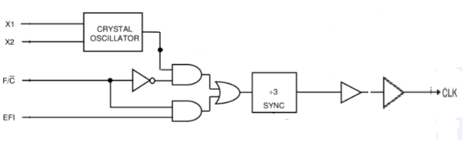

|  |  |  |  |
| --- | --- | --- | --- |
| EWULogo.png | | **EAST WEST UNIVERSITY** | |
| **Department of Computer Science and Engineering** | |
| **B.Sc. in Computer Science and Engineering Program** | |
| **Mid Term II Examination, Summer 2018** | |
| **Course:** | | **CSE442 – Microprocessors and Microcontrollers, Section-1** |  |
| **Instructor:** | | **Md. Nawab Yousuf Ali, PhD, Associate Professor, CSE Department** |  |
| **Full Marks:** | | **30 (15 mark will be counted for final grading)** |  |
| **Time:** | | **1 Hour and 20 Minutes** |  |
| **Note:** There are SEVEN questions, answer ALL of them. Course outcomes (CO), cognitive levels and marks of each question are mentioned at the right margin. | | | |
| 1. | Determine the actions of the following pins in 8086 microprocessor when   1. INTR is logic 1 2. TEST is logic 0 3. ALE is logic 1 | | [CO1, C3, 3] |
| 2. | Design a RAM chip with all control signals having 256KB of memory location. | | [ CO1, C3, 3] |
| 3. | Identify the addresses, data and control inputs, latches and status pins in the following bus buffering of 8086 microprocessor. | | [ CO1, C3, 4] |
|  |  | |  |
| 4. | Design an interface between a memory 271024EPROM and Intel 8088 microprocessor using a NAND gate decoder. Calculate the memory location for the EPROM. Determine the actions of control signals for reading data from EPROM. | | [CO2, C3, 7 ] |
| 5 | Design an address multiplexer for DRAM that contains only 16 address inputs, where it should contain 32-the numbered required addressing 4GB memory locations. Determines the pins functions for the operations. | | [ CO2, C3, 3 ] |
| 6 | Consider a software interrupt with BOUND instruction.  Write the outputs for the conditions in the box.  if (AX<(DATA+(DATA+1))) ; DATA is a one byte of a memory location  if (AX>((DATA+2) +(DATA+3))) | | [ CO2, C3, 3] |
| 7. | Illustrate the segment and offset addresses of the following interrupt vectors. Determine their types and memory addresses.   1. Double fault 2. Undefined opcode 3. Page fault | | [CO2, C3, 7] |

*\*\*\*GOOD LUCK\*\*\**